Daniela’s Blue Ribbon Apple Pie

Crust
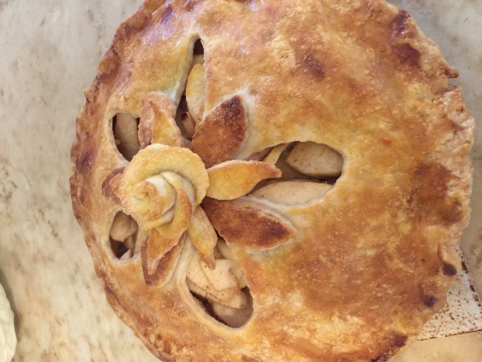
2 ½ cups ( 300 gr.) all-purpose flour, sifted
1 ½ tsp (10 gr.) sugar
¾ tsp (4.5 gr.) salt
1 stick (100 gr.) unsalted butter, cold
¼ cup (50 gr.) organic vegetable shortening
¼ cup very cold water (60 ml.) (with ice cubes)
1 egg, lightly beaten

Filling
3 lbs (1.36 kg) apples ( about 6 apples- I used Golden Delicious
You can use another baking apple or a mix of different varieties)
2/3 cup (135 gr.) white sugar
¾ tsp (3.7 gr.) cinnamon
1/8 tsp (1 gr.) allspice
1/8 tsp (1 gr.) nutmeg
1/8 tsp (1 gr.) salt
1 Tb (15 gr.) lemon juice, freshly squeezed
2-3 Tbs (15- 20 gr.) cornstarch or flour
2 Tbs (30 gr.) butter, unsalted

Egg wash
1 egg + 1 tsp water

Cooking equipment:
a 9 inch (23 cm.) pie plate (preferably glass)
a sifter, a rolling pin, a pastry brush, a pastry cutter (or food processor), a baking sheet, parchment paper, plastic food wrap, a mixing bowl

Step 1: Make the crust.
Mix the flour, salt and the sugar. Cut the shortening into the flour using a pastry cutter or two knives. Cut up the butter into small pieces and cut it into the flour. Rub the butter completely into the flour with your fingers until it is pea size. Beat the egg with the water, then drizzle it evenly over the dough. Lightly stir the dough together with a fork. The dough should be damp. If the dough is too dry, add 1-2 Tbs ice water to the dry parts. Bring it together into a ball. Divide it into 2 equal pieces. Wrap each piece in plastic wrap and shape each into a disk. Refrigerate at least 30 min. or up to 2 days.
Note: You can make the dough in the food processor fitted with the metal blade. Pulse flour, sugar and salt until combined. Cut butter into small cubes. Add shortening and butter and pulse 10 times until it resembles cornmeal mixed with bean-size bits of butter. Beat the egg and water together, add and pulse 1 to 2 times, but don’t let the dough form into a ball in the machine. Remove the blade and bring the dough together by hand. Divide it into 2 equal pieces. Wrap each piece in plastic wrap and shape each into a disk. Refrigerate at least 30 min. or up to 2 days.

Step 2 Roll out the bottom crust
Lightly dust the counter with flour. Pat a disk flat with your hand. Lightly dust the dough with flour. Roll it out with a rolling pin into a circle 2 inches bigger than your pie dish. Gently put the dough in the pie plate. Trim and fold the edges. Refrigerate it while you make the filling.

Step 3 Make the filling
Wash and pat dry the apples. Peel them and slice thinly. Pour the lemon juice on the apples. Mix the sugar with the cornstarch (or flour) and the cinnamon, allspice, nutmeg and the salt. Pour the mixture over the apples. Mix well and set aside.

Step 4 Roll out the top crust
Lightly dust the counter with flour. Take the second disk out of the refrigerator and pat it flat with your hand. Roll it out with a rolling pin into a circle 2 inches bigger than your pie dish. Make vents by cutting slits in the dough or using pretty cookie cutters.

Step 5 Assemble the pie
Take the pie plate with the bottom crust out of the fridge. Pour the apples into it. Cut up 2 Tbs butter into small pieces and spread them all over the apples. Put the top crust on. Trim it so it hangs ½ inch over the edge of the pan. Fold the edges down, pinching both crusts together. Crimp as desired.

Step 6 Bake the pie
Beat 1 egg with 1 tsp water and brush the top of the pie with it. Sprinkle with a little bit of sugar. Bake at 425 degrees F for 15 min. Lower the temperature to 350 degrees F and bake for 45 min. The pie is ready when the crust is golden and the fruit is bubbling lightly. The juice may spill and make a mess. So, to catch any drips, place a sheet of parchment paper on a baking sheet on the rack below the pie 15 min. before it’s done.

Enjoy! You can serve it with vanilla ice cream. Yum!

