Zucchini Pesto
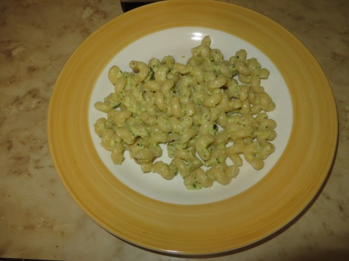

Ingredients:

2 zucchini, grated
some pine nuts, walnuts or almonds
1 to 2 cups grated parmesan cheese
7-8 basil leaves
salt
6 tablespoons olive oil
garlic, optional
pasta (I used cellentani but you can use whichever you like)

Directions:

- Squeeze all the water from the grated zucchini.
- Put the zucchini, garlic, pine nuts, parmesan, basil, olive oil and the salt into the blender and blend until creamy.
- Add salt if desired.
- Cook the pasta according to package directions. Add a bit of salt to the boiling water.
- Drain the pasta. Mix it with the zucchini pesto. Yummy!

Margherita Carrero, Italy
RWW volunteer

